**Step 1: Select the “Enhanced Financial Analysis” and “Gemini 2.5 PRO” model**

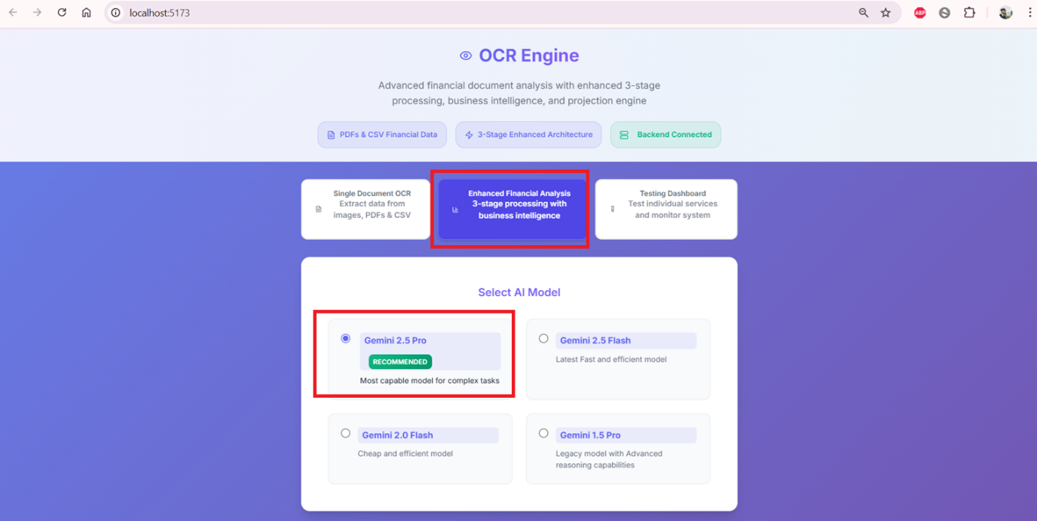

**Step 2: Upload P&L statement and Balance Sheet (CSV files) and click “Analyse Document”  
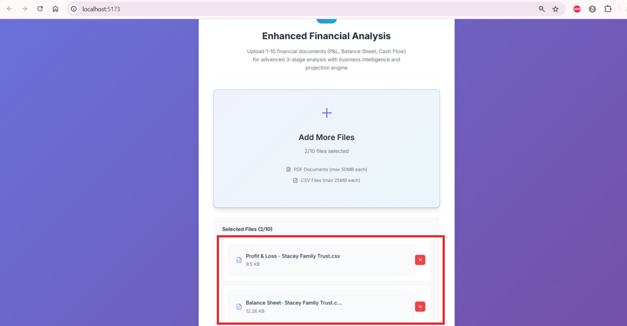**

**Step 3: Wait for the backend to process using a 3 way projection pipeline (See the documentation link) – IT TAKES ROUGHLY 5 minutes to give the results.  
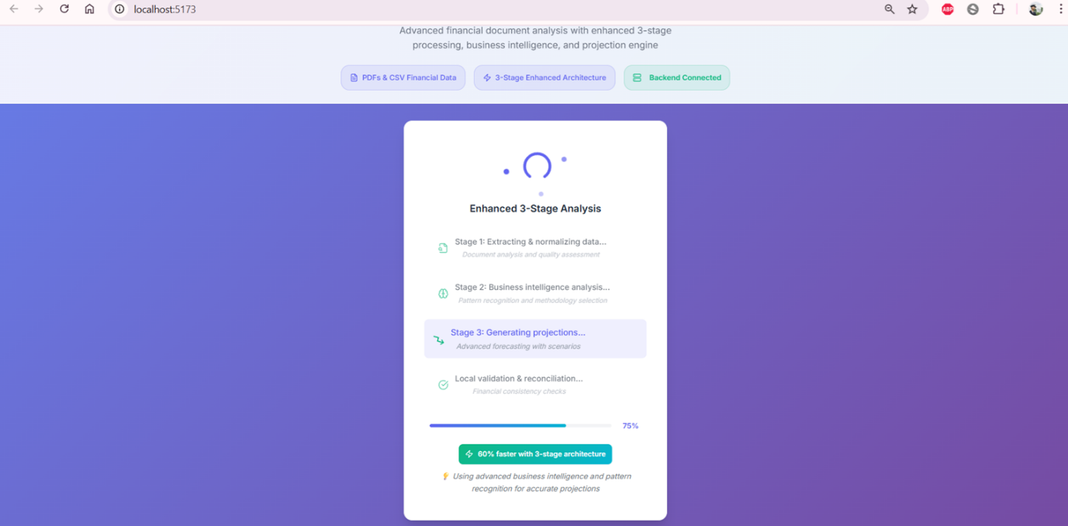**

**Comprehensive Logging at Backend for each Stage:  
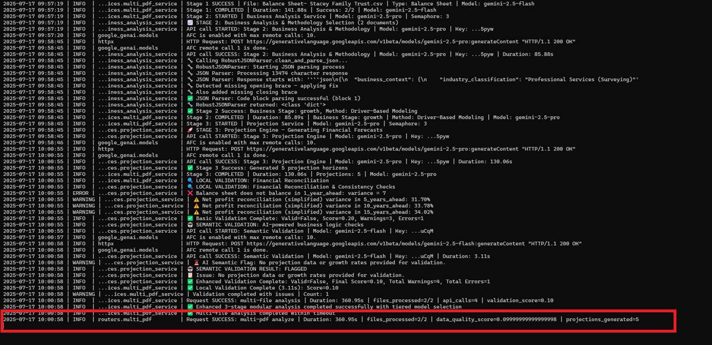**

**Output on Completion: Thorough Detection of Industry Types, market, competition and seasonality.  
**

**Forecasting Methods and algorithms selected and why (after considering 3-4 best algorithm as per the data)**

**Appropriate projections are made with confidence levels:  
**

**Projections with “Good” and “Bad” scenarios:  
**